Android Developer Bootcamp
Basic Widgets Screen
Workshop #04

🎯 Purpose
This workshop helps you practice designing a simple Android screen using XML layout only.
You will use common UI components such as TextView, ToggleButton and ListView.
🧩 Problem
Design a simple widgets screen UI in Android using XML.
The screen should contain the following elements:
📝 Title Text
• A TextView at the top of the screen
• Example text: "User Preferences"
🔀 Notification Toggle
• A ToggleButton below the TextView
• Text ON: "Notifications ON"
• Text OFF: "Notifications OFF"
📄 Item List
• A ListView below the Spinner
• Display area for showing a list of items
How to Solve
Checkout the workshop from Git Repo:
- git clone -b
- Open the root folder inside Android Studio
- Open activity_main.xml
- Add a ToggleButton
- Arrange all components vertically
- Run the application
🎯 You Will Achieve
After completing this workshop, you will understand:
• How to use TextView in Android XML
• How to use ToggleButton in Android XML
• How to use ListView in Android XML
• How to arrange views using LinearLayout
• How to create a simple screen without Java/Kotlin code
📸 Screenshots
Before Implementation

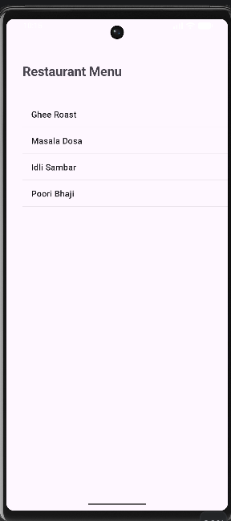
After Implementation
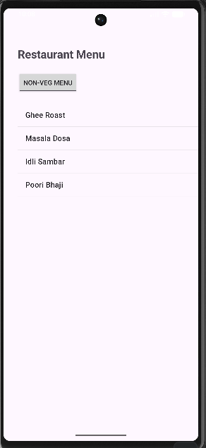
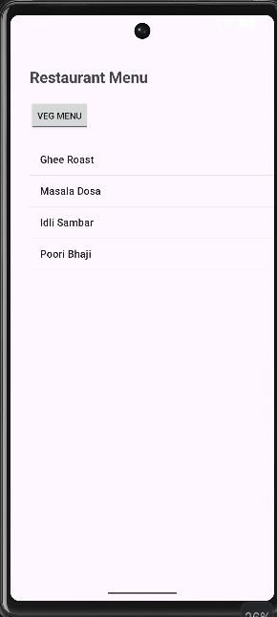
How to submit your workshop
Push your project back to the same git branch using command:
git add .
git commit -m "Completed Basic Widgets Screen Workshop"
git push origin
🚀 Happy Coding!

